

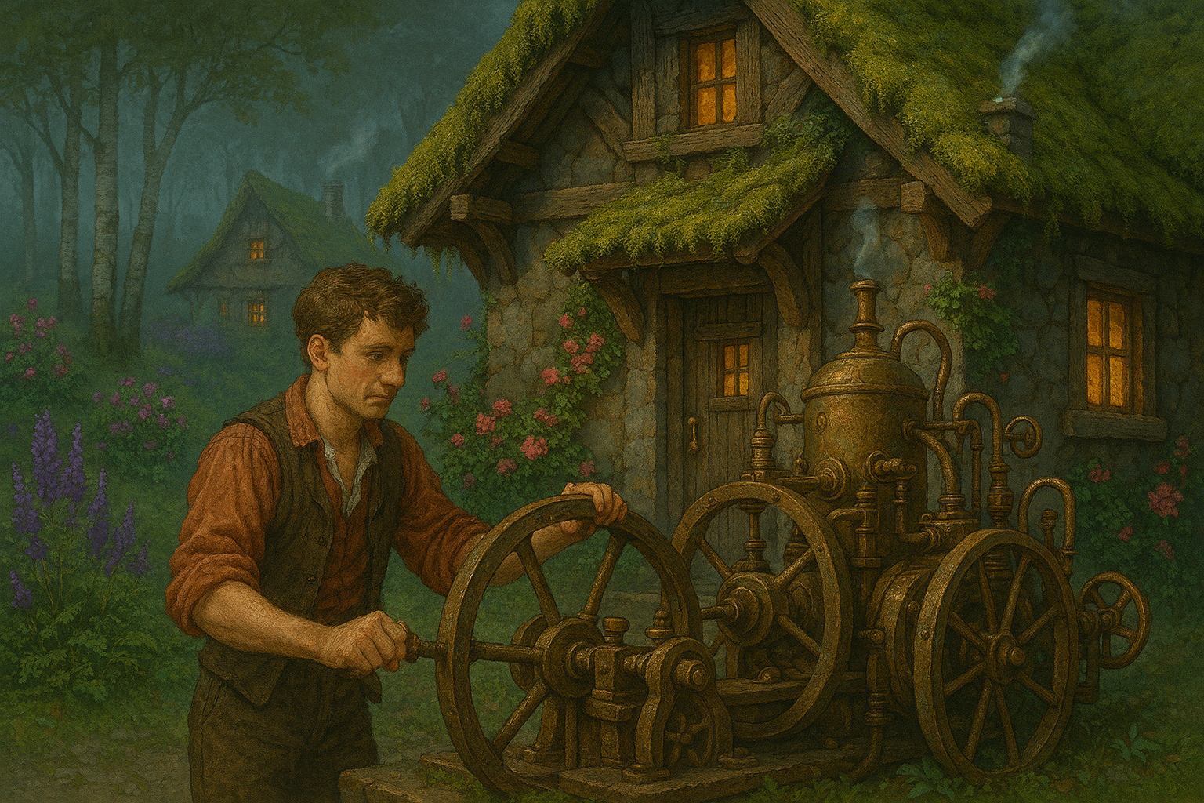In the moss-draped village of Fernloft, nestled between fog-slicked hills and whispering birchwoods, lived a curious tinker named **Vellimer Quorchleff**. No one knew where Vellimer came from—he simply appeared one morning with a rickety cart full of glittering brass parts, humming to himself in a language no one recognized. His eyes were mismatched—one green, one a shade of deep violet—and his coat always smelled faintly of lightning.

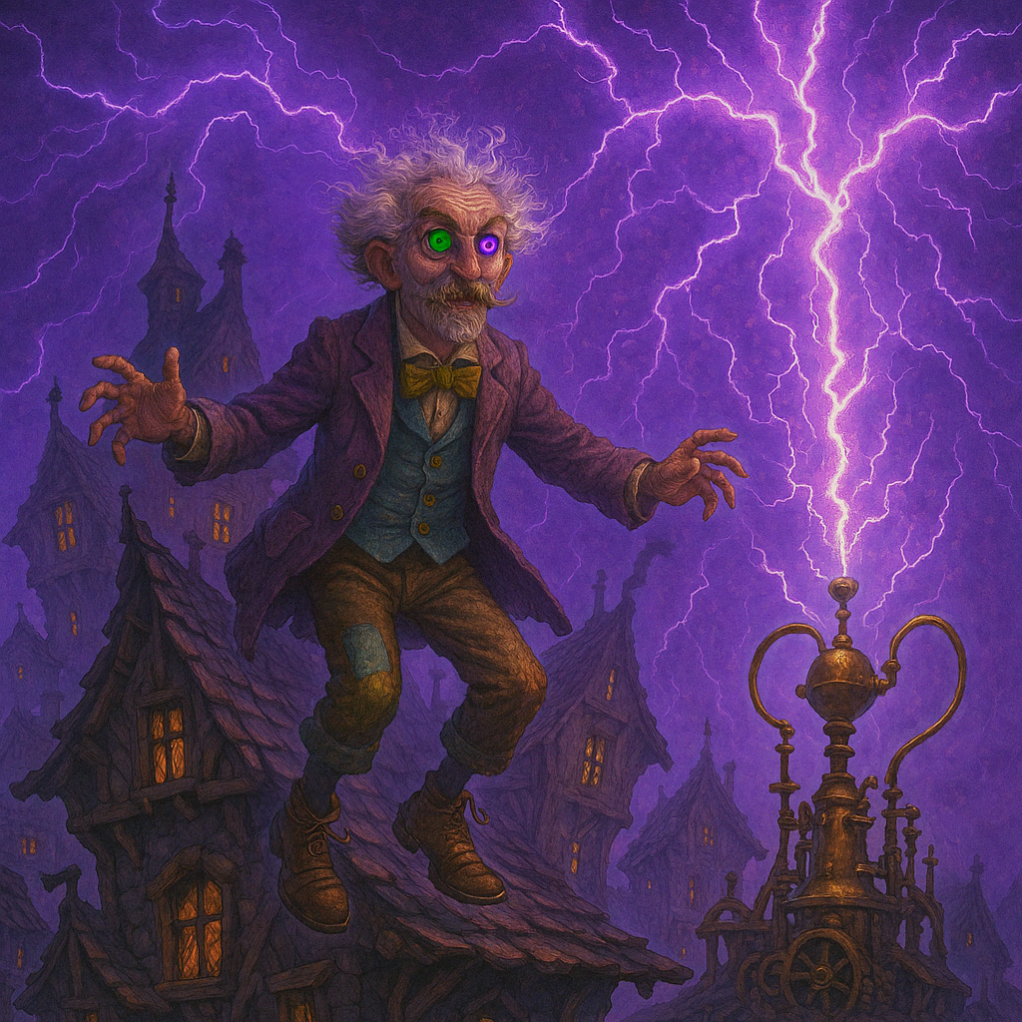Vellimer wasn’t like the others in Fernloft. While villagers wove baskets or tended sheep, Vellimer crafted oddities: a teapot that sang lullabies, a walking stick that told jokes, and once, a chandelier that predicted the weather by sneezing. The townsfolk were equal parts fascinated and unnerved, but they tolerated him because, every so often, one of his inventions changed a life for the better.

One moonless night, a storm brewed that had no wind, no rain—only silence and a sky bruised with static. Vellimer stood atop his crooked roof with a brass rod, waiting. At precisely midnight, a bolt of white-purple lightning struck his contraption, and for a brief moment, the entire village glowed.

The next morning, children found their shadows now wagged like dog tails. The baker’s loaves sang warm harmonies. Even the river near Fernloft began to run backward, whispering secrets in bubbles. The villagers stormed Vellimer’s home, demanding an explanation.

He stood at his door, wearing boots that hovered half an inch above the ground. “I only wanted to see,” he said, “what the world might do if given a little nudge sideways.”

They exiled him, of course.

But as the years passed and the river kept whispering secrets—some of them useful—the villagers began to miss Vellimer Quorchleff. His inventions, though odd, had made life more magical. Rumors spread that he now lived in the clouds, teaching thunder to dance and convincing stars to blink in Morse code.

To this day, no one knows where Vellimer truly went. But every so often, when the weather sneezes or a broom hums to itself, someone in Fernloft smiles and mutters, “Quorchleff was here.”